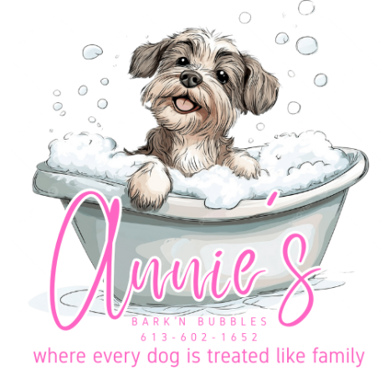
CLIENT & DOG INTAKE FORM

1. Client Information
Full Name: ____________________________________________________
Address: ______________________________________________________
Phone: ________________________ Email: _______________________

2. Dog Profile & Health Information
Dog's Name: ___________________ Breed: _____________________
Age/DOB: _____________________ Weight: ___________________
Sex: [ ] Male [ ] Female Spayed/Neutered? [ ] Yes [ ] No
Vet Clinic: ___________________ Vet Phone: __________________
Vaccination Status: [ ] Rabies (Req.) [ ] Bordetella (Req.)
(Proof must be emailed to anniesbarknbubbles@gmail.com prior to booking)
Medical Conditions / Allergies: ____________________________________

3. Behavior & Grooming Details
Temperament: [ ] Calm [ ] Anxious [ ] Energetic [ ] Nervous
Aggression / Known Triggers: ____________________________________
Grooming History / Special Requests: ______________________________

GROOMING AGREEMENT & POLICIES

1. Aggressive / Dangerous Pets: You must disclose if your pet has bitten or shows aggression toward people, animals, or grooming procedures. Muzzles may be used for safety. Annie's Bark 'n Bubbles reserves the right to refuse or stop services at any time, and an Aggressive Dog Fee may apply.
2. Health, Medical Issues & Senior Pets: Grooming can be stressful, especially for senior or medically compromised pets, and may worsen existing conditions. These pets will be groomed for comfort and cleanliness only. In case of an emergency, Annie's Bark 'n Bubbles may seek veterinary care. We will attempt to contact you first, then transport your pet to your preferred or nearest vet. All veterinary costs are the owner's responsibility.
3. Mat Removal: Severely matted coats may require shaving. De-matting can cause stress, skin irritation, cuts, or reveal pre-existing conditions. Risks include redness, itching, abrasions, or coat changes. Additional charges apply for de-matting.
4. Accidents & Safety: While every precaution is taken, grooming carries inherent risks (nicks, cuts, nail quicking, etc.), especially if pets move. For safety, do not knock or enter early—this can excite your pet and create risk. If a pet becomes too excited, the session may end early and full charges will apply.
5. Hold Harmless Agreement: By signing below, you release Annie's Bark 'n Bubbles and its staff from liability for any injury, loss, or condition (known or unknown). Terms may be updated at any time and apply to all pets groomed.

Acknowledgment & Signature
Thank you for trusting us with your fur family!

Client Name (Printed): ____________________________________________________
Signature: ________________________________________ Date: _________________

